SPARK: Simple Play Adaptations to Reference for Kids

TalkingBrix 2
Description: | Image:
TalkingBrix 2 is a set of three single message, Augmentative and Alternative Communication (AAC) devices that supports those with speech challenges. The devices are lightweight and can easily mounted to a variety of surfaces. A clear snap on cover protects a picture that may be selected to represent the communication message used on the device. Symbol overlays (pictures) are not included with the TalkingBrix2, however any communication device overlay maker can be used to create the pictures such as Boardmaker, Lesson Pix or the free AbleNet Symbol Overlay app for iPad. A single TalkingBrix 2 activation surface is approximately 2.5 inches, and it weighs 4.8 oz. A micro-USB cord that is included is used to recharge the device. | 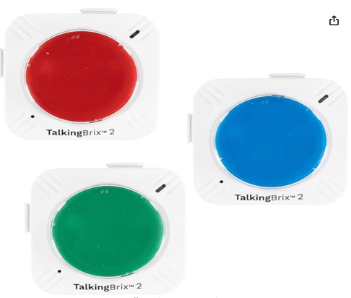  Purchasing Information  Getting Started Video  Advanced Features Video  Quick Start Guide  Users Guide  Trouble Shooting Support  Free Overlay App for iPad

Who Might Benefit?
Those who…
• Have difficulty understanding only oral directions given by others.
• Have difficulty talking and communicating with others.
• Have difficulty completing multi-step activities (schedules, routines, directions).
• Have adequate fine motor skills to isolate a finger to press and activate the button on the device. This skill is specific to this device, however there are many different access methods that can be used with other communication devices if needed.

Why Use?
Provides an opportunity to…
• Make choices.
• Comment to others.
• View a multi-sensory (visual and auditory) non-transient cue (remains within view) to support following schedules, routines, and directions.
• Hear verbal directions paired with a visual cue as often as needed.
Instructions for Use: | Adaptation Ideas:
Environmental Considerations  - Easily use in almost any environment because of the small size, weight, and easy transportability. The device can be carried in a pocket, fanny pack, or purse for easy access.  - May be difficult to use in loud environments as the speaker on the device may not be loud enough to be heard by the child or communication partner over loud environmental noise.  - The user of the device will need to learn when it is appropriate to use the device in quiet environments in the same way that children who are speakers learn when they need to talk or not talk in quiet environments.  - If the device is used as a part of a child’s total communication system it should be available in the child’s environment and without restriction, at all times.  Positioning  - Can be used in most any position due to the size, portability, and minimal weight (on a tabletop, attached to a wall with Velcro, placed on the floor, positioned on a slant board, etc.).  - Interact with the device in different positions such as sitting, standing, prone (Tummy Time position), supine (laying on their back), kneeling, etc.  Alternate Positioning  - Interlock at least 3 TalkingBrix 2 together to allow greater options of choices.  Basic Play/Use  - Place a picture symbol into the covered frame that represents the word that will be recorded.  - Slide the switch on the back to "REC".  - Press and hold the switch top.  - Begin speaking when the light is blinking to record a message for up to 10 seconds.  - Slide the switch on the back to "On" to play message.  - Press the switch top to activate the message.  Extended Play/Use  - Instructions - Provide directions, such as what to wear or what's next on the schedule.  - Requests - Make requests, such as ordering food, asking questions, or requesting a song.  - Participation - Participate in activities, such as turning the page, taking a turn, or repeating a phrase from a story (e.g. What do you see?).  - Information - Share information, such as upcoming events or activities.  - Communication - Add communication to toys or appliances.  - Game - Make games interactive, such as by modifying a game to talk or playing Simon Says.  - Classroom - Use as labels for areas or centers, as teaching prompts, or to greet others upon entering the classroom every morning.  - Self Care - Use to indicate the need to go to the bathroom or provide the picture and recording to prompt a child to take a potty break.  Play/Use with Others  - Increase opportunities for communication by sending a message to others. | Optional Additional Materials/Supplies  - Velcro  - Foam Board  Build It Up  - Velcro a plastic bottle cap to the button to build up the surface.  - If the size of the button is too small for the child to activate, other single message devices are available in the OCALI Lending Library that have larger activation surfaces.  Stabilize It  - Can be velcroed on most any surface so it doesn’t move away when the child tries to activate the button.  Add Sensory Cues  - Add sensory cues to the activation button such as puffy stickers, puffy paints, different textures.  - The color of the button can also be changed if needed.  Communication Support  - Vocabulary words would depend on the activity supported by the AAC device.  Alternative Uses  - Multiple TalkingBrix 2 can be linked together or velcroed onto a foam board strip to allow a child: choices among several toys or activities, provide a visual and auditory cue for the sequence and steps in an activity, provide first/then support, or to sequence and construct a simple sentence, etc.

Additional Considerations:
- Please keep in mind the device only has 10 seconds of recording time. If additional recording time is needed there are other single message devices available in the OCALI Lending Library that could offer extended recording and play time.

Resources:
- 101+ Ideas for Single Message Communication Device Use - This article focuses on Ablenet single message devices, but the activities can be used with the GoTalk One device also.
- Using Single Message Devices - Tip of the month from TalkLink discussing the use of single message devices.
- Making the Most of Single Message Output Devices - A list of ideas on how to use single message devices provided by Enabling Devices.
- Keep Talking - This poster provides a quick reference and reminders for staff about the communication opportunities you can create with single message AAC devices. The poster was created by CALL Scotland, in collaboration with Tony Jones of TalkSens.

Ohio Early Learning Standards:
- Depending on the activities supported by the AAC device a wide range of Early Learning Standards could be impacted.

Words to Encourage Play/Use
Push  | Listen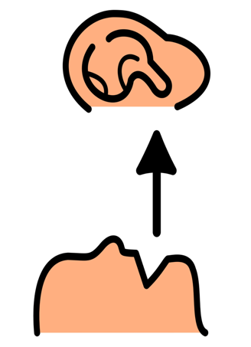 | All Done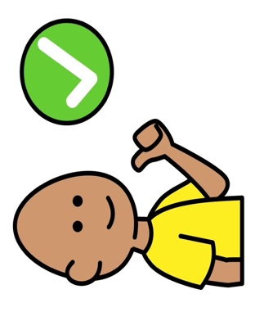
My Turn | Your Turn | More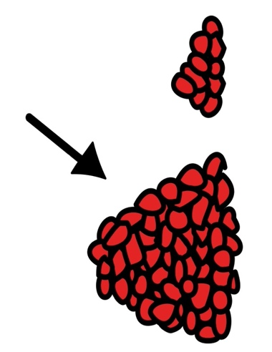
Wait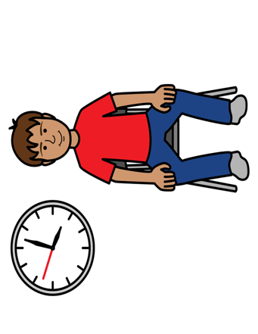 | Stop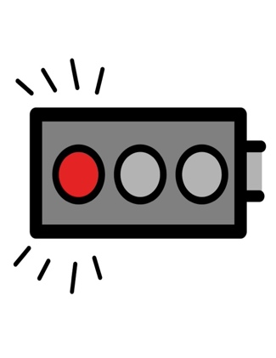 | Go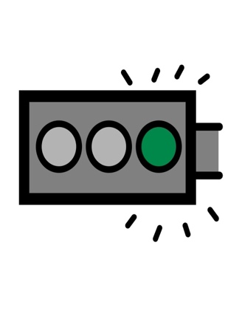
*”Adaptations” adapted from: Haugen’s Modes for Adapting Toys based on materials from the "Let's Play" Project at the University of Buffalo
PCS is a trademark of Tobii Dynavox, LLC. All rights reserved. Used with permission.

